

**Bachelor of Business Information technology**

**BBT 4102: Cryptography and Network Security**

**Encryption and Decryption Application using Triple DES algorithm**

**Done by:** 112209 BALUGE AKIZA Innocent

112162 Rosine Biringanine Ninawabana

97292 Tom Bill Glinton

**Lecturer: Totona Loyeiye**

**Date of Submission: 30th August, 2021**

**DESCRIPTION**

. In this project, we created a web-based system called CIPHA, using PHP for the backend and algorithm implementation and HTML and CSS for the front-end, to make our user interface appealing to the user’s eyes.

Through our application, a user can send an encrypted a message and send the encrypted message to the recipient via email and the encryption key is sent via SMS.

The recipient will use our application to decrypt the message sent. For this purpose, he will input the encrypted message sent via email and the encryption key, which is the decryption key as well, sent via SMS.

The encryption/decryption key is an alphanumeric 10 digits long sent once and used for a specific encrypted message.

The algorithm was implemented using PHP

Our SMS is sent using the Africa Talking API and the email is sent using PHP mailer.

**CLOSE LOOK AT THE FUNCTIONALITES**

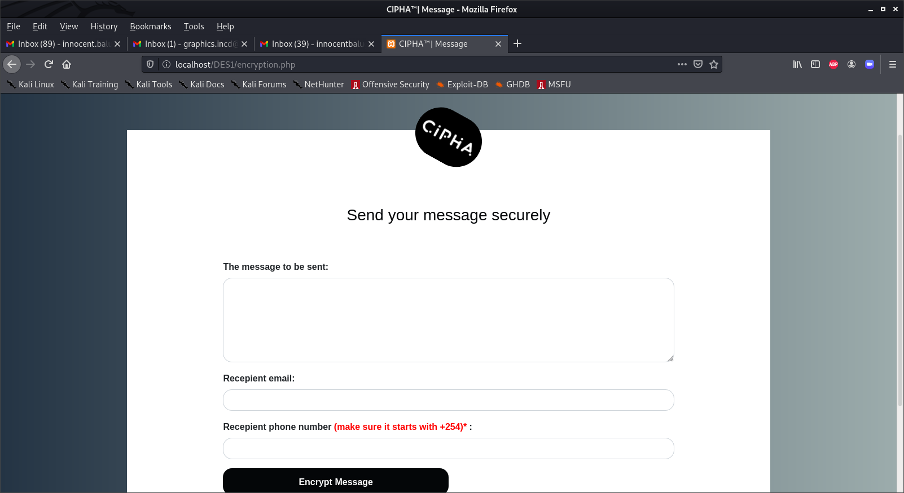

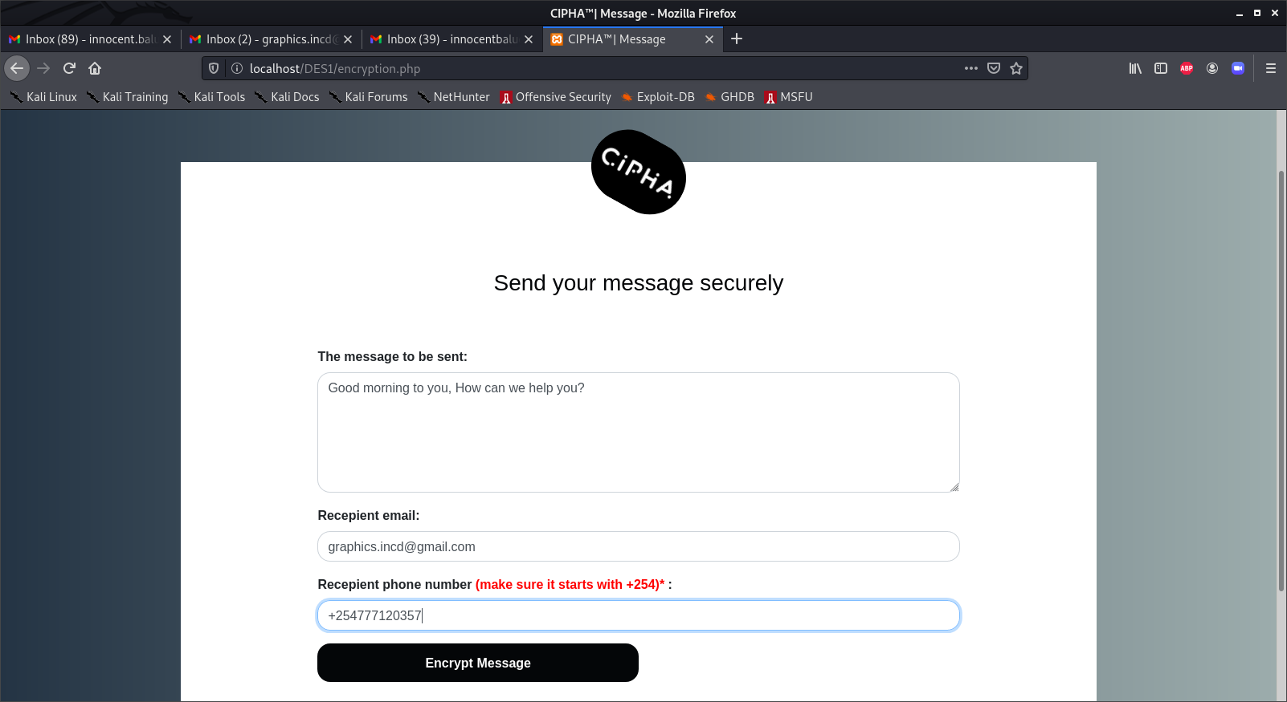

In the above screenshots, the system will prompt the user to input the message to be encrypted and sent, the recipient email address and his phone number where the key will be sent.

We separated the email from the key for security purposes, because it is more secure if the message and the message are sent on different media and not via the same medium.

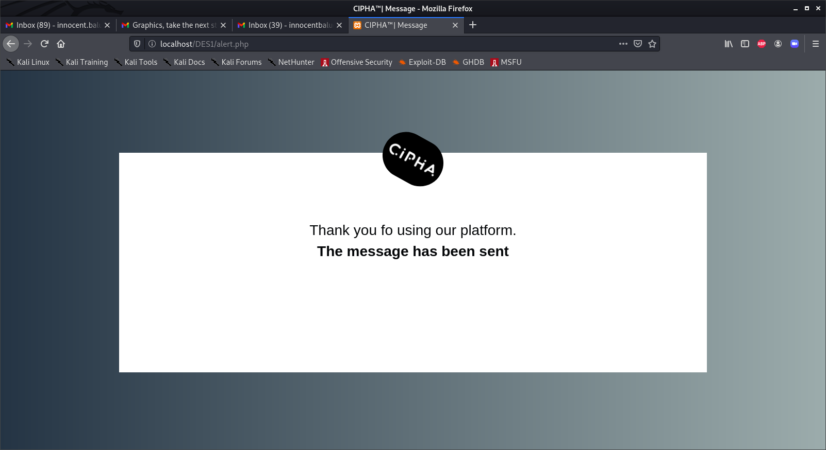

After clicking on send your message, the above screenshot will appear to show the user that his message was successfully sent.

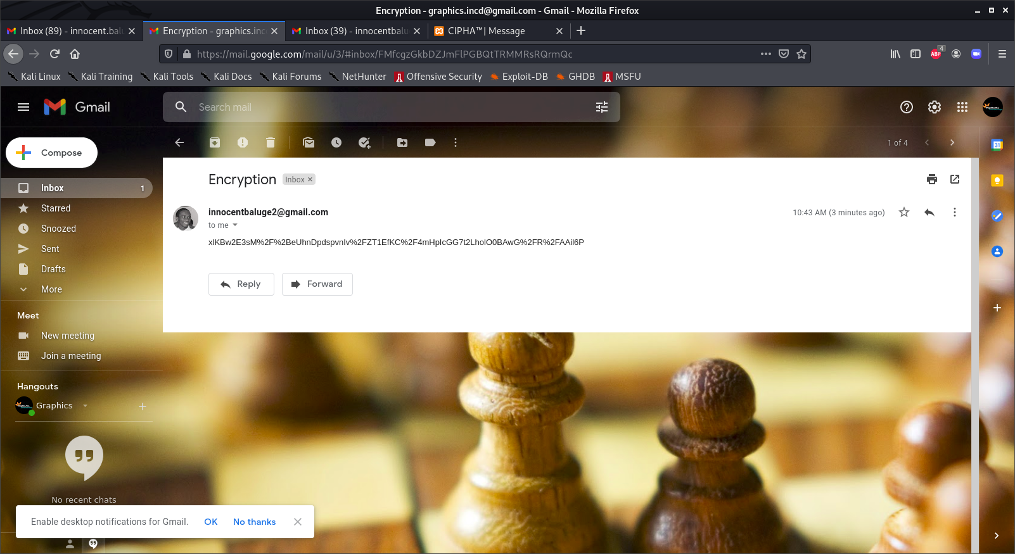

This is the encrypted message that the recipient will receive and below is the encryption/decryption key sent via SMS.

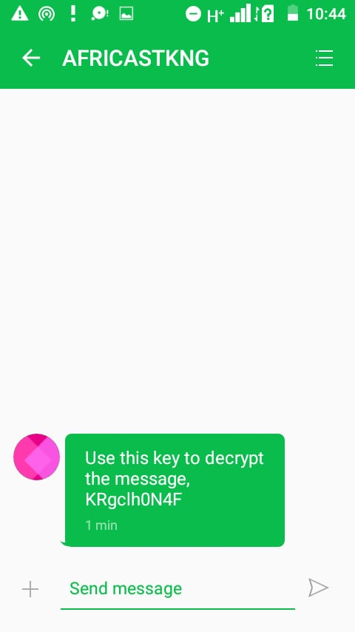

After receiving the message, the user will decrypt it by entering the encrypted message and the key is their respective fields. As shown below:

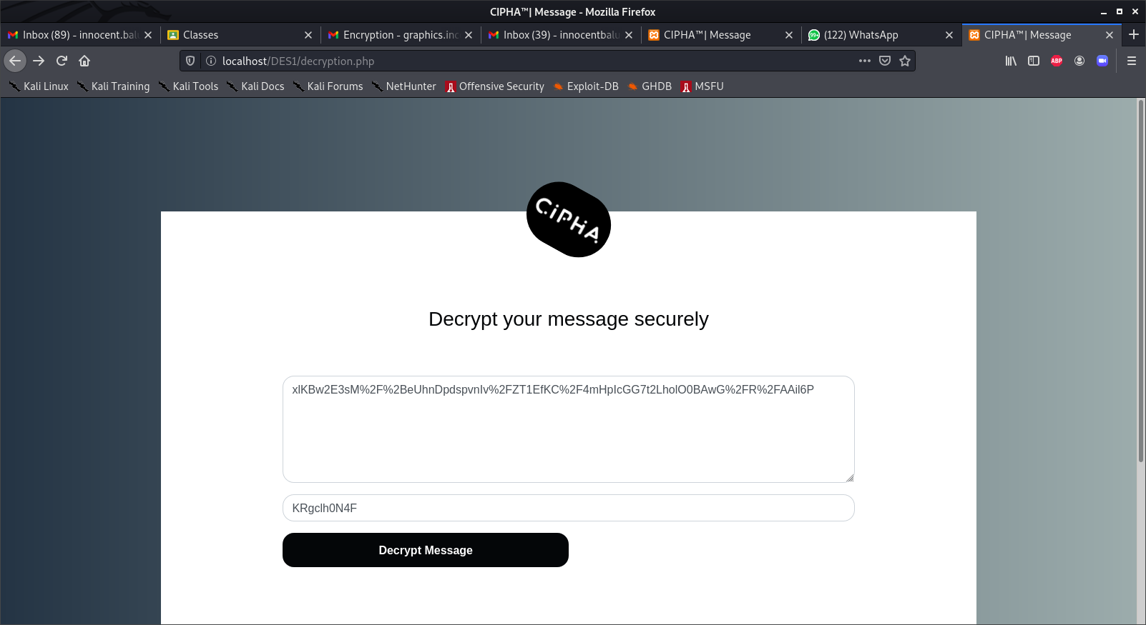

Then the message will be decrypted as in the below screenshot.

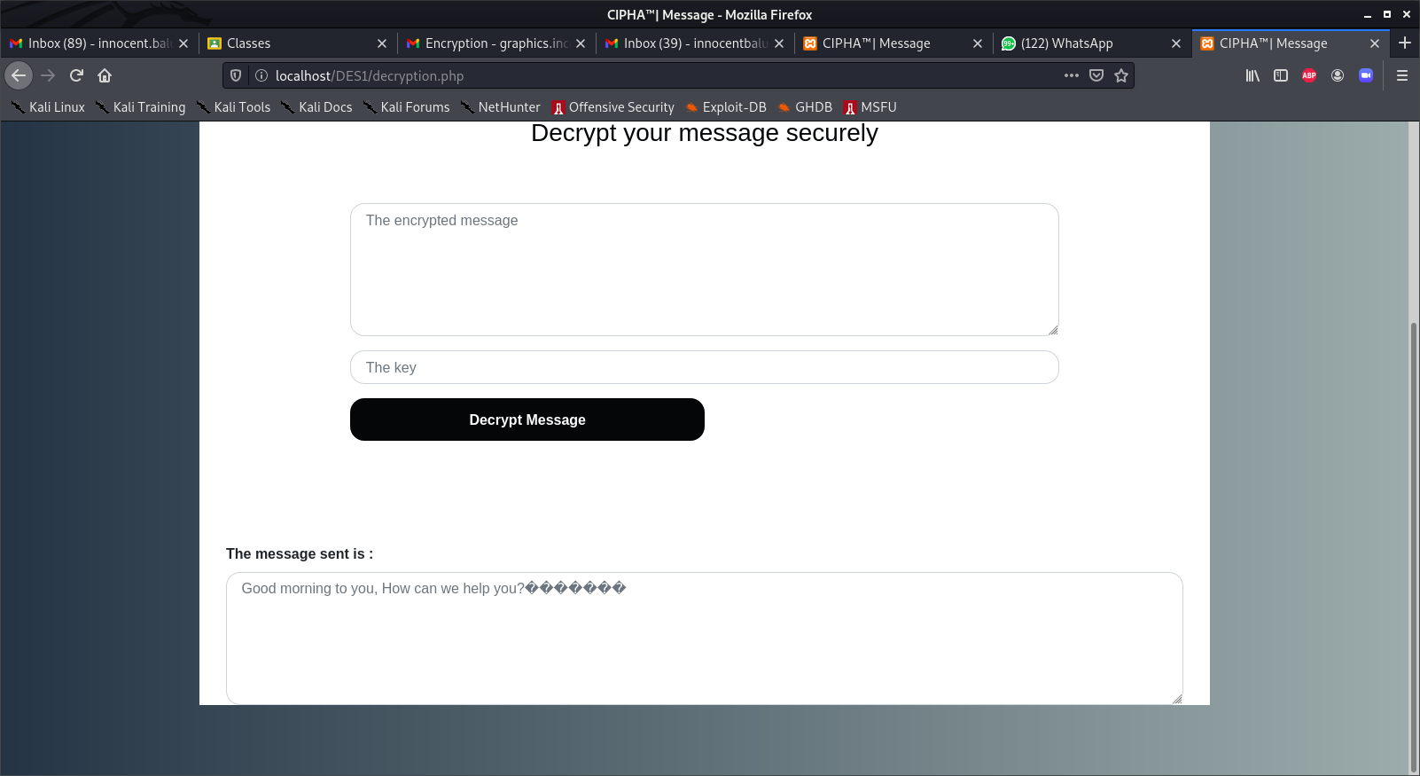

**SAMPLE SOURCE CODE**

